# Exercise: DOM

Problems for in-class lab for the ["JS Advanced" Course @SoftUni"](https://softuni.bg/courses/js-advanced). Submit your solutions in the SoftUni judge system at <https://judge.softuni.bg/Contests/1802/Exercise-DOM>

## Chat Room

Write a **function** to create the functionality of **a chat room.**

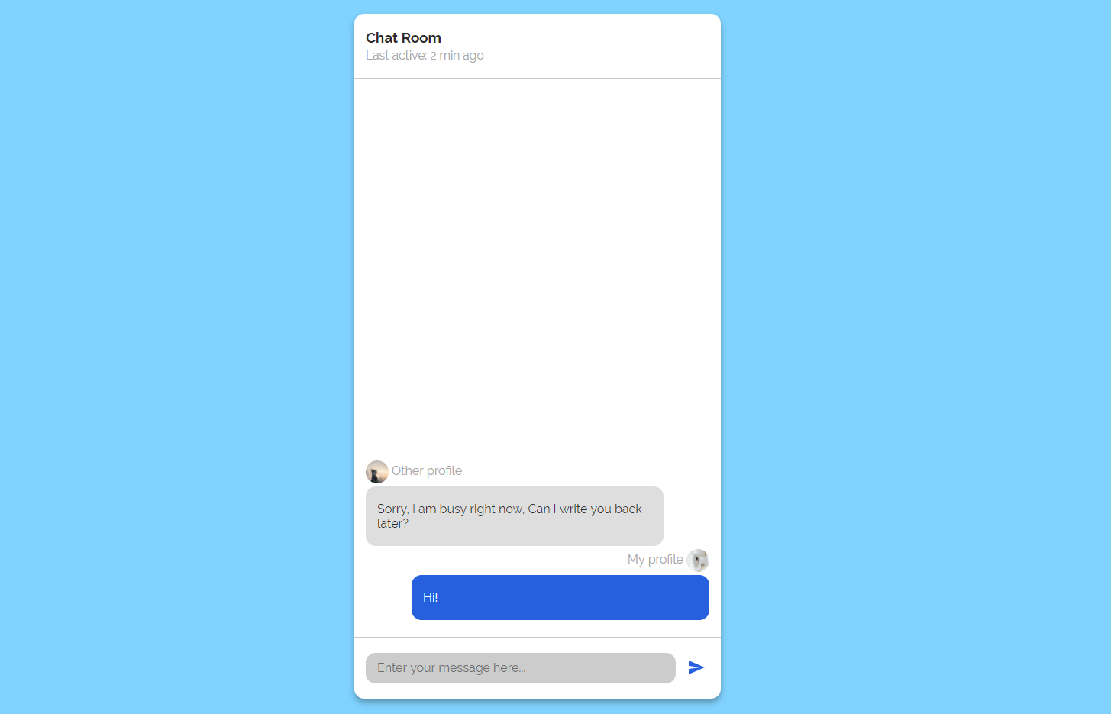

**Note: Do not forget** to **add event listener** to the **send button!**

**The new** div **element with class message my-message** should contain the current message that is about to be send.

The **current** div should be appended to the div with an id="chat_messages".

**The input should be cleared on each click of the send button**.

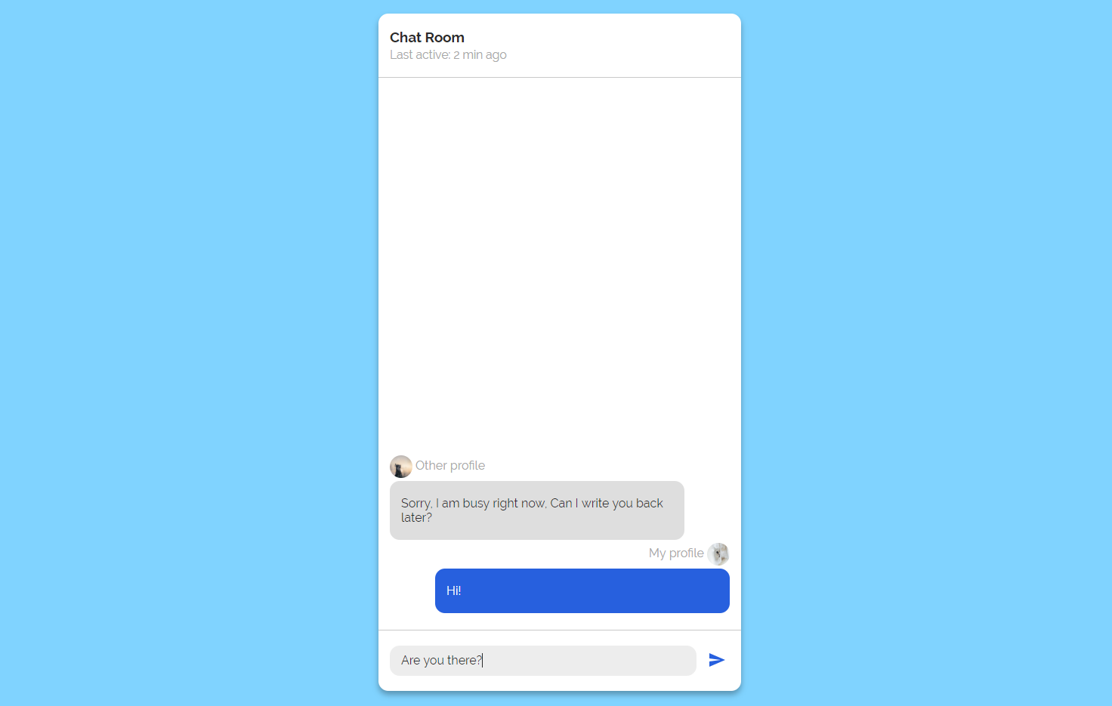

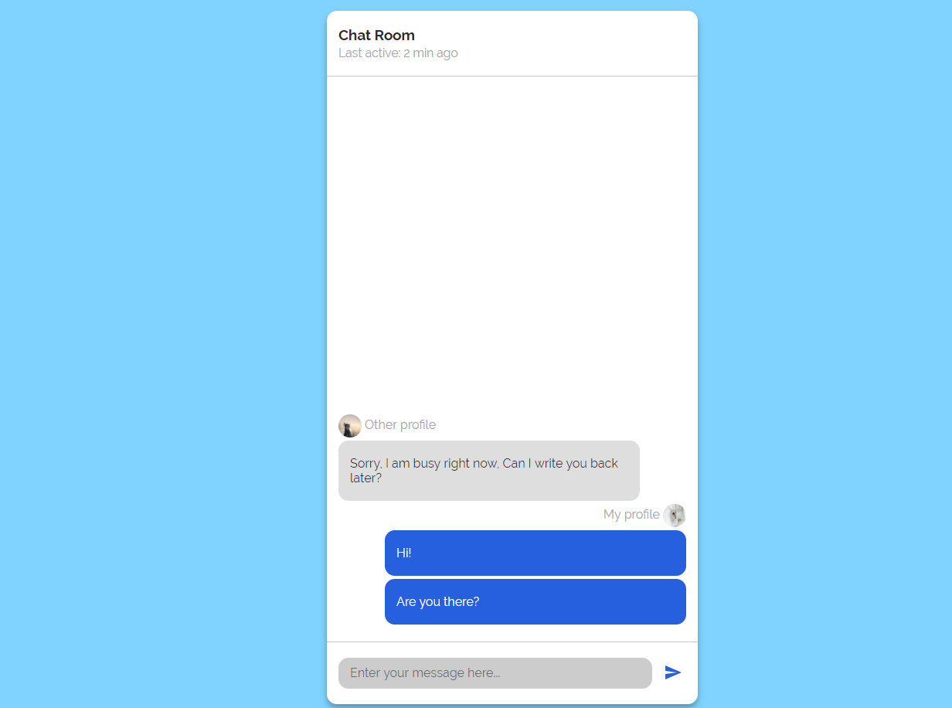

## Number Convertor

Write a functionthat **converts** a **decimal** **number** to **binary** and **hexadecimal**.

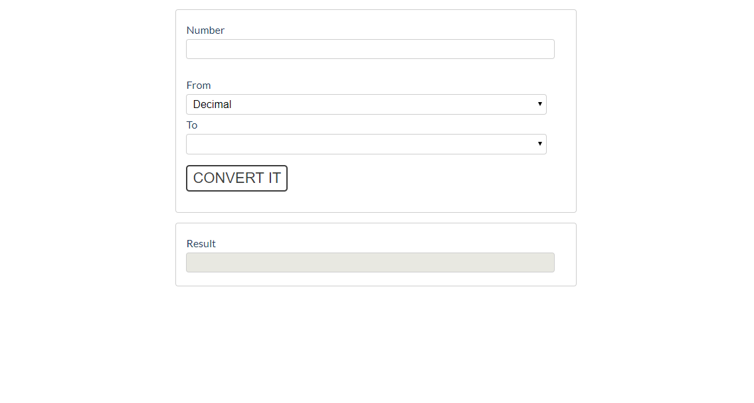

The given number will always be in **decimal format.** The "From" select menu will only have a

Decimal option, but the "To**"** select menu will have **two options**: Binary and Hexadeicmal.

This means that our program should have the functionality to **convert** **decimal** to **binary** and

**decimal** to **hexadecimal**.

Note that "To**" select menu** by default is empty. You have to insert the two options (**'Binary'** and **'Hexadecimal'**) inside before continue. Also they should have **values** ('**binary**' and '**hexadecimal**').

* When the [Convert it] button is **clicked**, the expected result should appear in the [Result]input field.

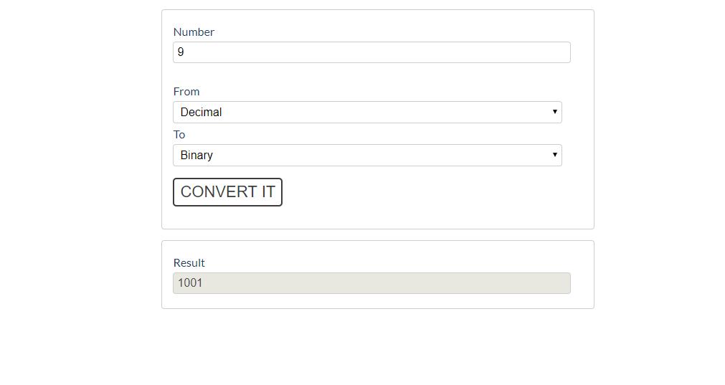

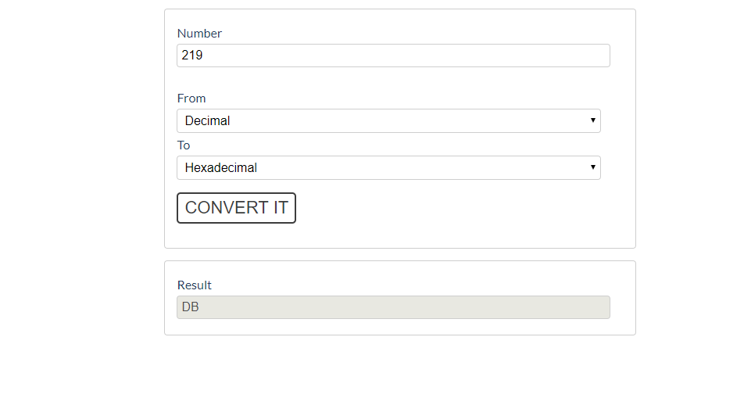

## JavaScript Quizz

Write a function that has the functionality of a quiz.

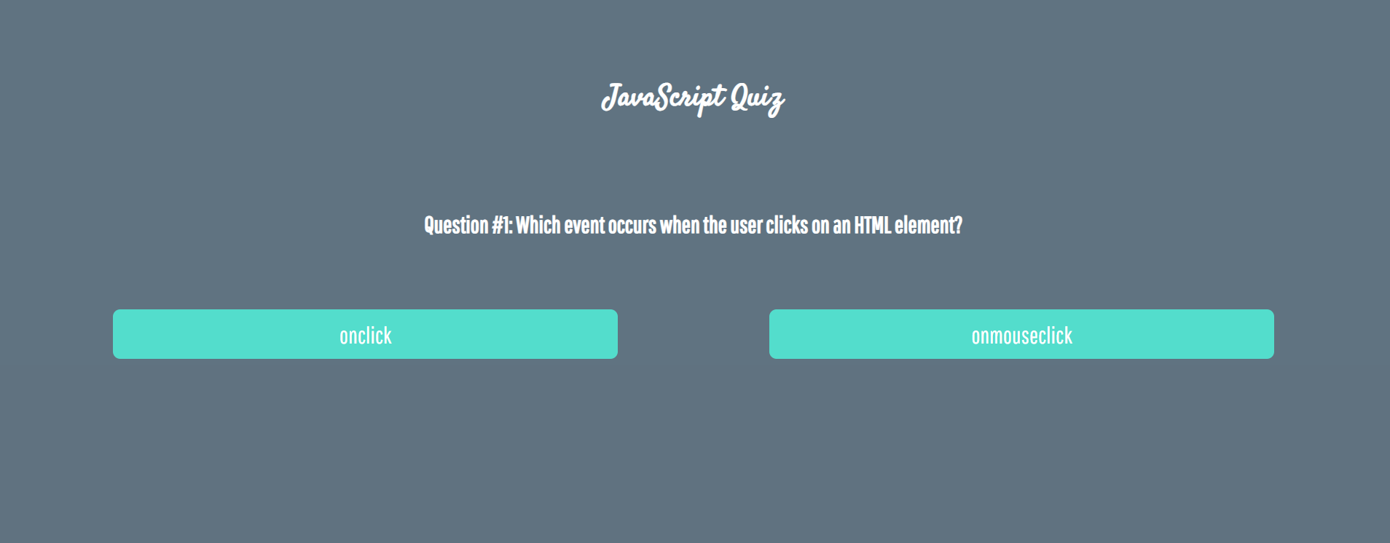

There are three **sections** that contain **one question** **and 2 possible answers.**

**The right answer is only one!**

When one of the **list elements is clicked,** the next section **must appear (if any…)**.

After all three questions have been answered, the result div must **appear.** (Use **'none'** and **'block**' to hide and show the question sections)

If all questions are answered correctly, you should prin the following message:   
"You are recognized as top JavaScript fan!"

Otherwise, just print "You have {rightAnswers} right answers".

The right answers are (onclick**,** JSON.stringify() **and** A programming API for HTML and XML documents).



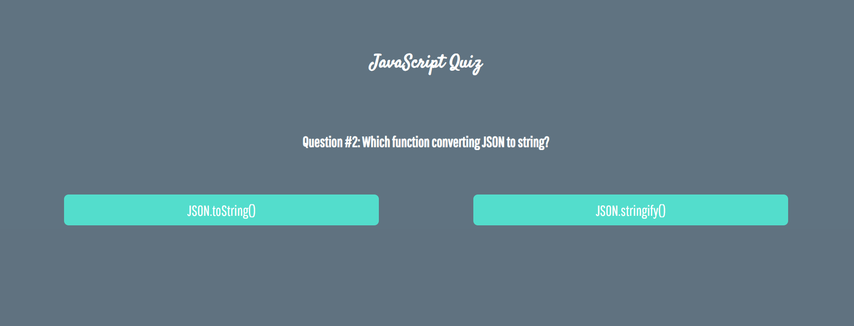

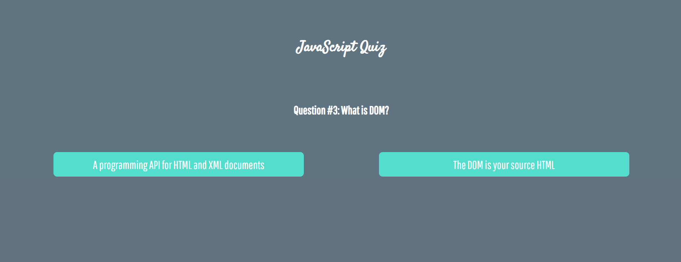





## Numpad Calculator

Write a function that implements a calculator that has the following functionalities:

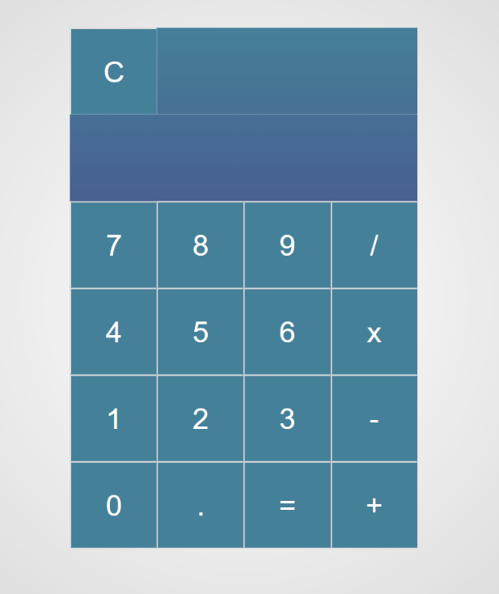

When one of **the buttons is clicked, its value** should be shown in the "Expression" **field** (#expressionOutput).

For instance, if we click on the button with value 9, the expected result should be:

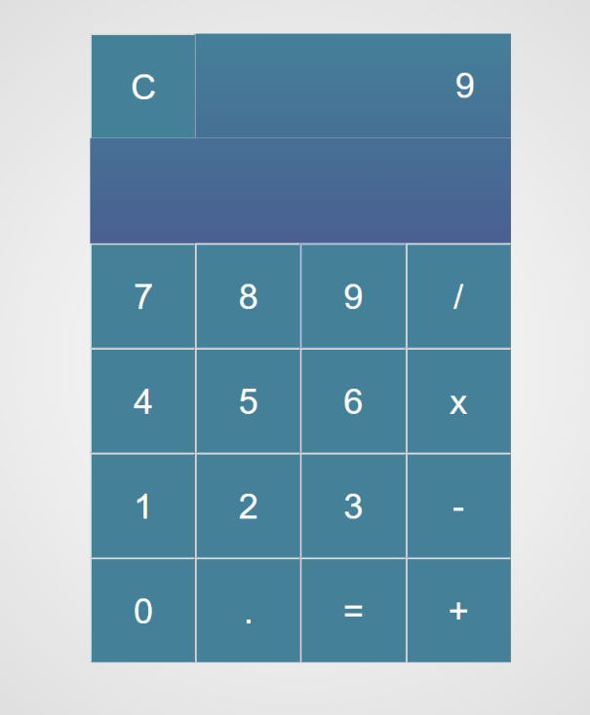

If the **current** Expression field (#expresisonOutput) contains the whole math expression (**left operand**, **operator** and **right operand**: **Example: 9 + 2**), the expected result should be:

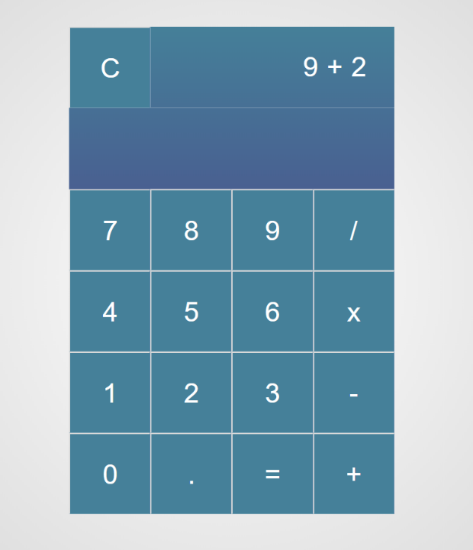

When the **equal sign "**=**" is pressed, the result of that expression** should appear in the Result field (#resultOutput)

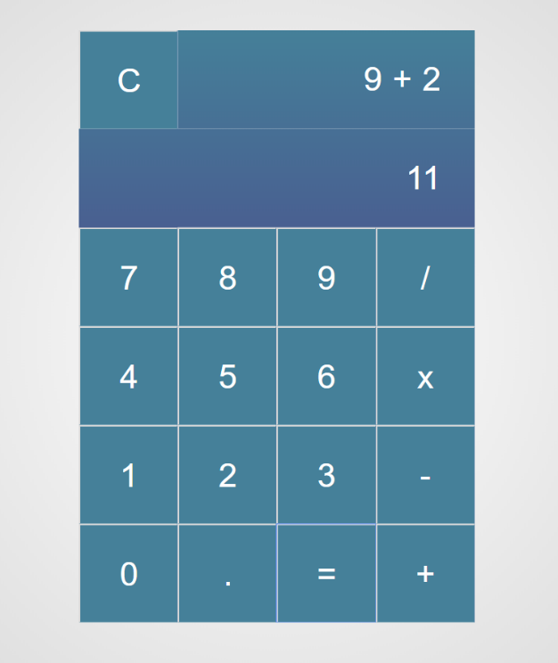

Otherwise, if we create an invalid expression such as "99 +" (**without second/right operand**) and we hit the equal sign "=", the expected result should be:

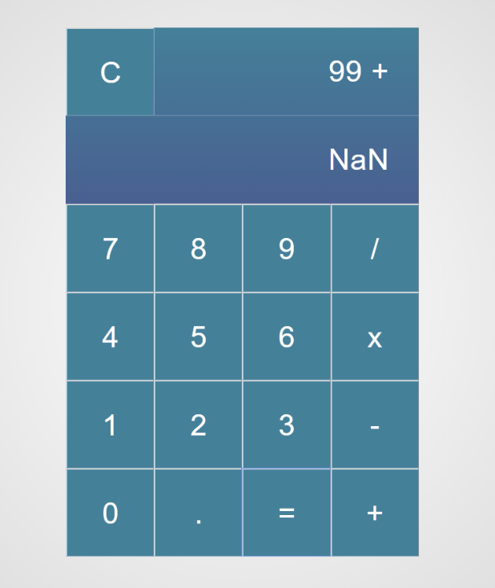

The "Clear" button should **clear both** Expression **and** Result **fields (**#expressionOutputand#resultOutput**)**

For instance, if we have the following expression:

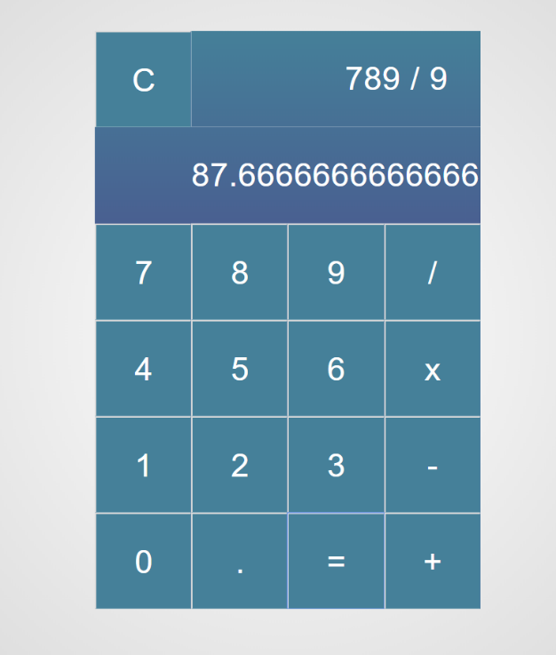

And we press "Clear", the expected result should be:

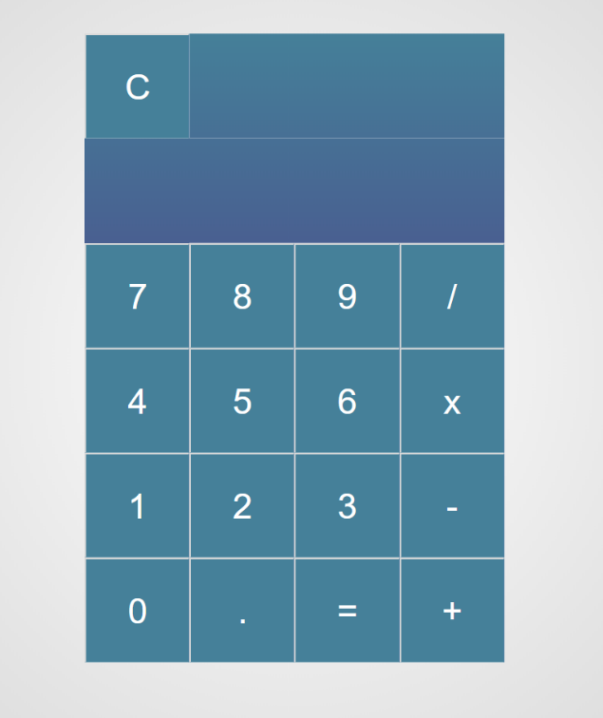

## Order the Names

Write a **function that orders names alphabetically**.

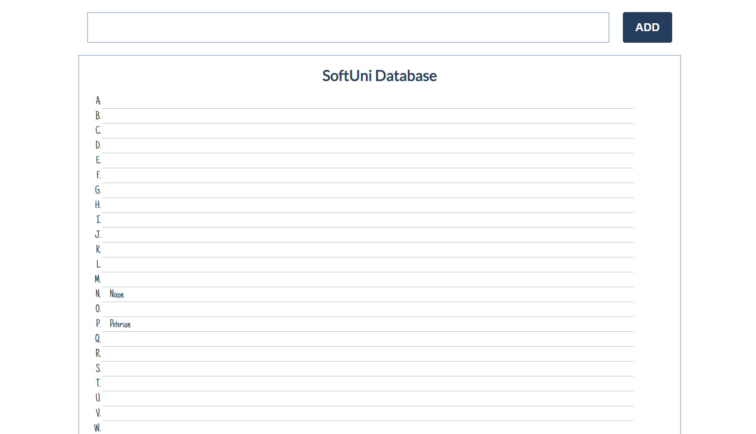

You will receive a **name of a student as an input**. When the "Register" button is **clicked**, you should

add the given student name in the SoftUni Database, while **keeping** the **alphabetial order**.

For instance, if we register **David,** his name should appear in the **D** column.

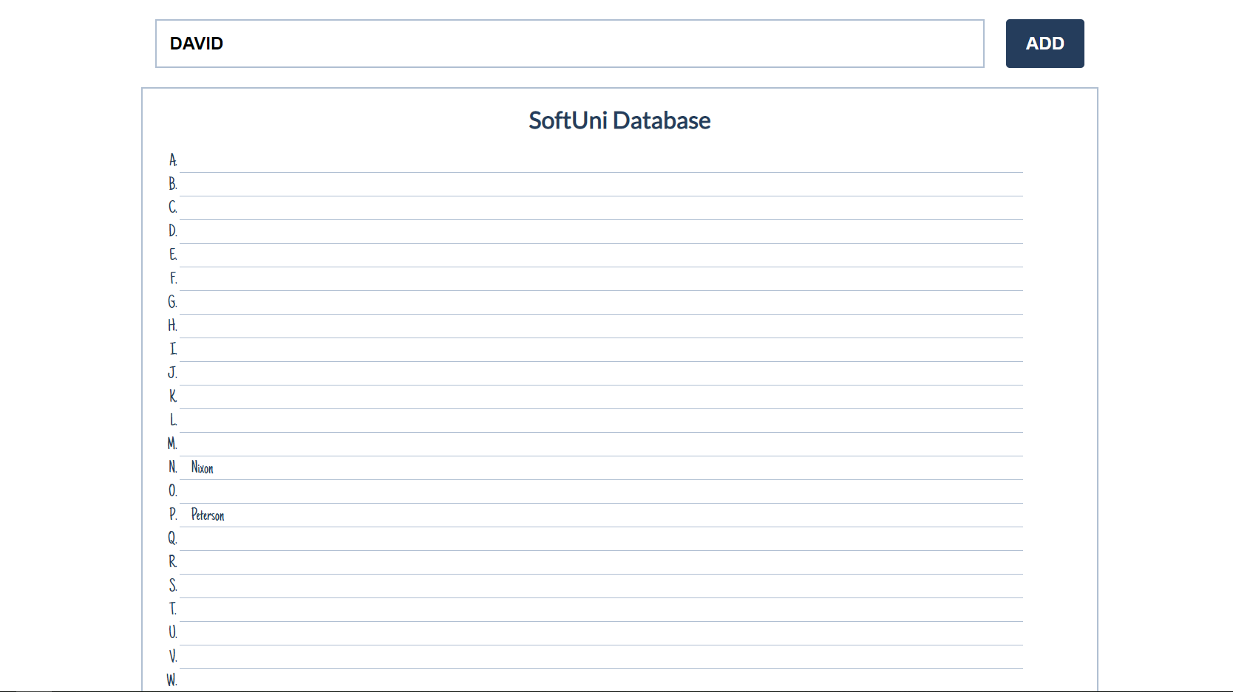

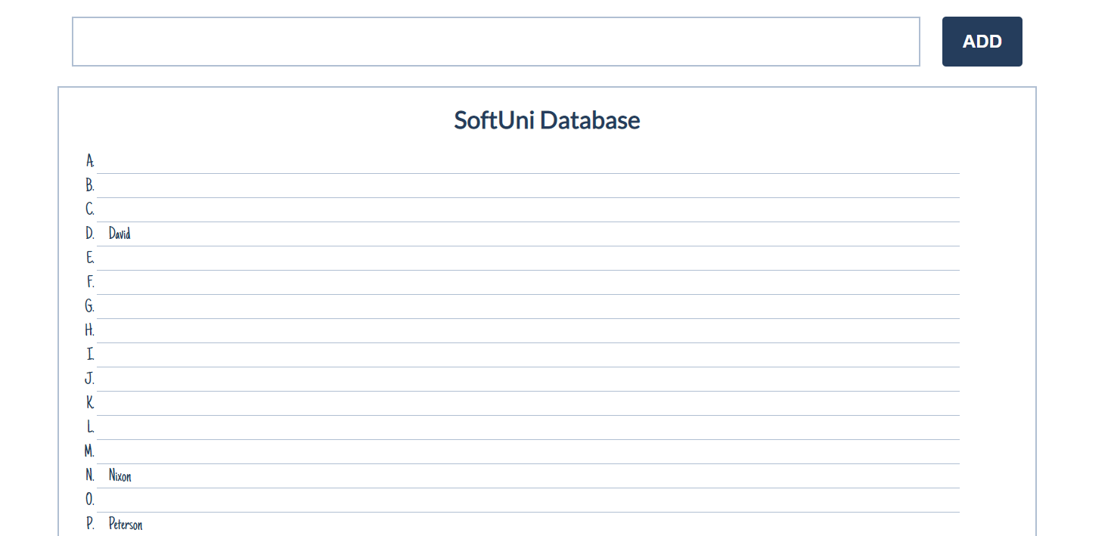

If you **receive more than one name with the same starting letter**, you should **join all names** by a

comma and a space (", ").

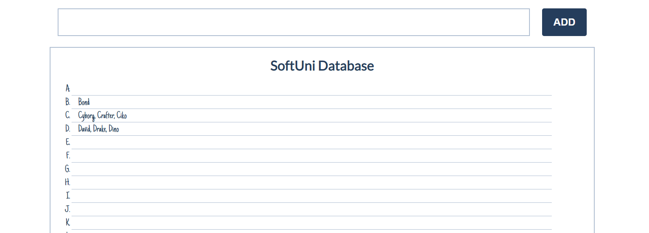

## Table – Search Engine

Write a function that **searches** in a **table** by given input.

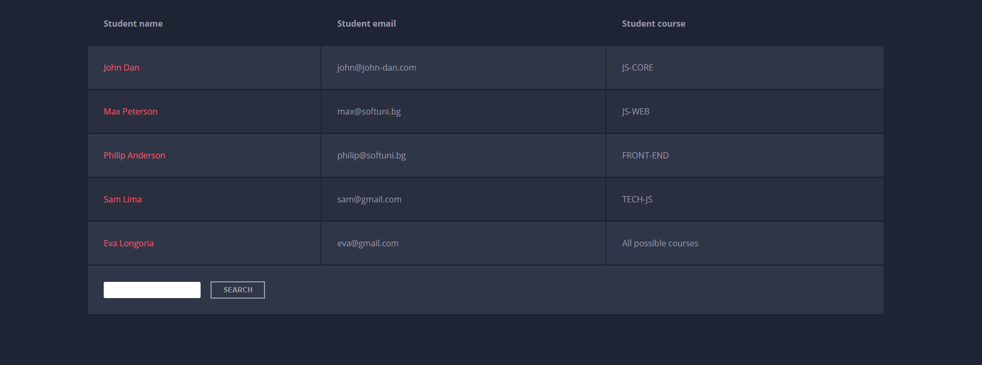

When the "**Search**" **button** is **clicked**, go through all cells in the table except for the first row (Student name, Student email and Student course) and check if the given input has a match (check for both **full words** and **single letters**).

If any of the rows contain the submitted string, add a select class to that row. Note that more than one row may contain the given string.

Оtherwise, if there is no match, **nothing should happen**.

**Note:** After every search ("Search" button is clicked), **clear** **the input field** and **remove** **all already selected classes** (if any) from the previous search, in order for the **new search** to contain only the **new result**.

For instance, if we try to find **eva:**

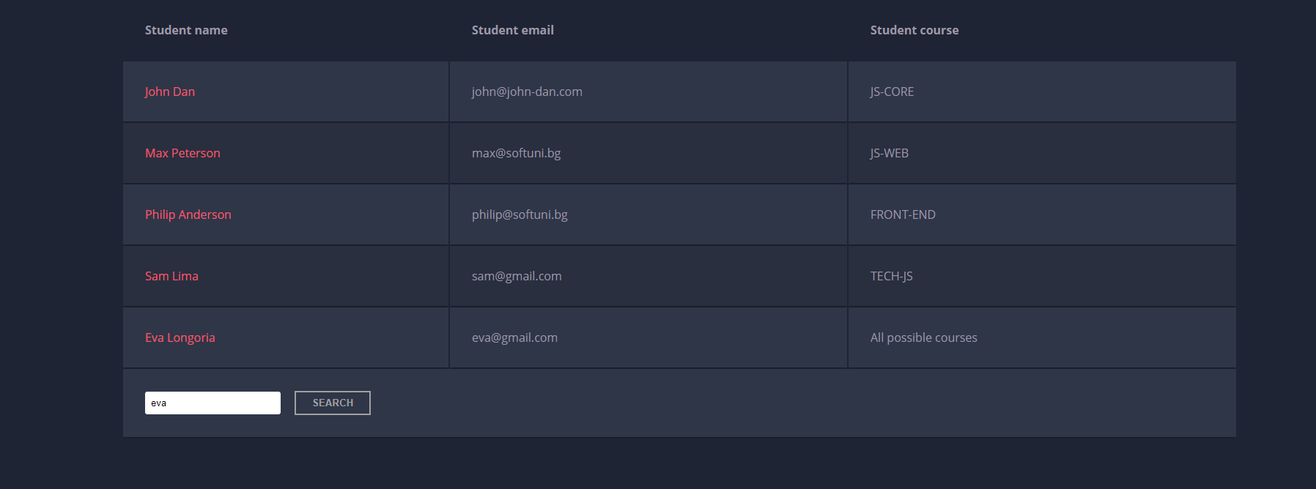

The result should be:

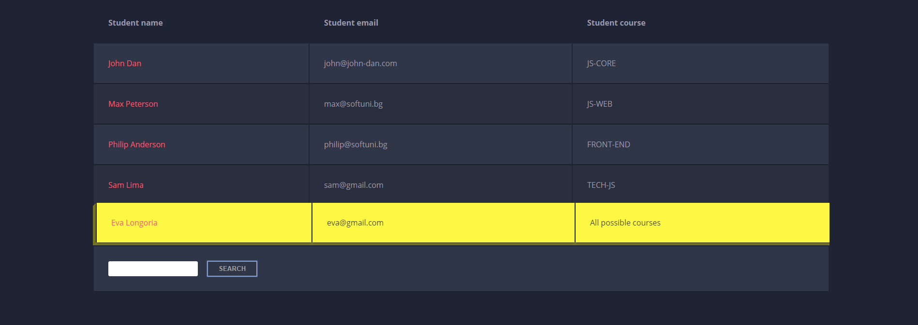

If we try to find all students who have email addresses in **softuni** domain, the expected result should be:

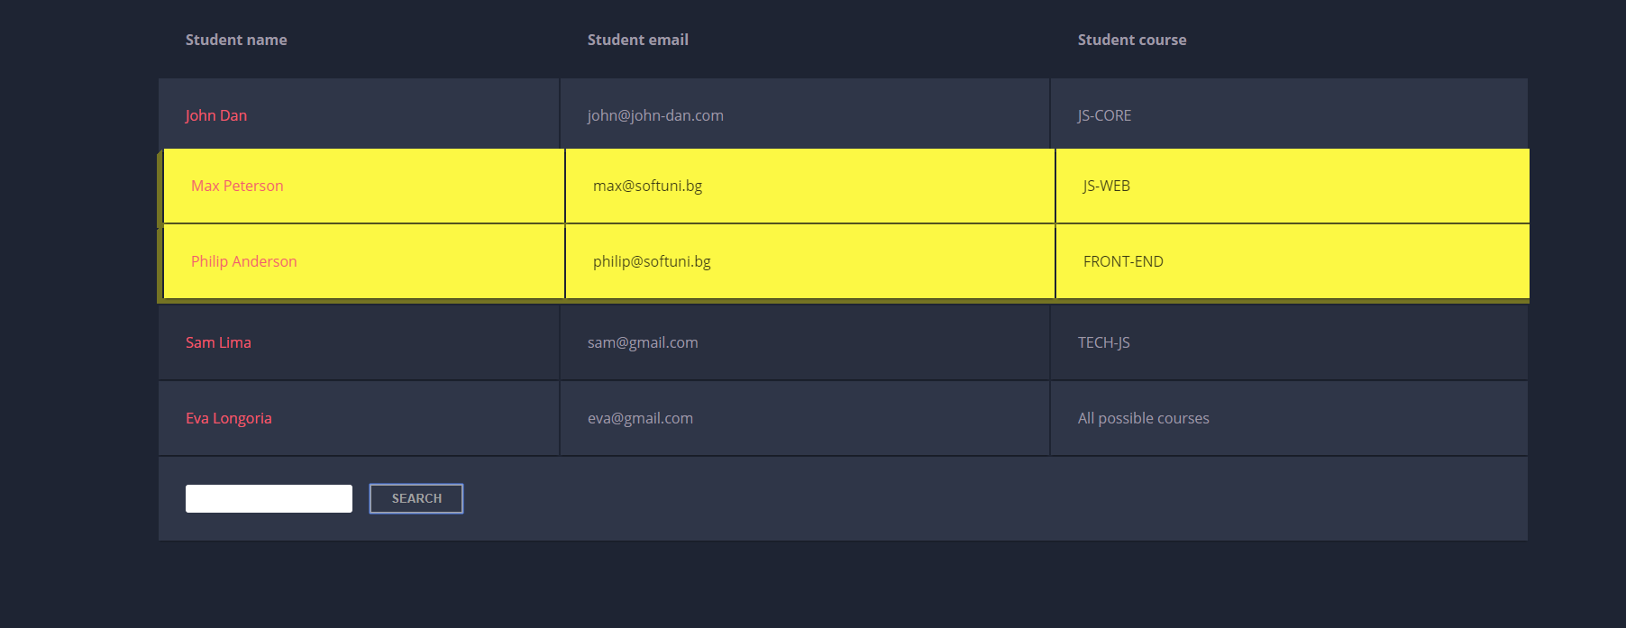

## * Shopping Cart

You will be given some products that you should be able to add to your cart. Each product will have a name**,** pictureand aprice.

When the **"Add"** button is clicked, append the current product to the textarea in the following format: **"Added {name} for {money} to the cart.\n"**.

When the button **"Checkout"** is clicked, calculate the **total money** that you need to pay for the products that are currently in your cart. Append the result to the textarea in the following format:

**"You bought {list} for {totalPrice}."**

The list should contain only the **unique products**, separated by **", "**. The total price should be rounded to the second decimal point.

Also, after clicking over "**Checkout**" and every from above is done you should **disable** **all** **buttons**. (You **can't** add products or checkout again, if once checkout button is clicked)

### Examples

